# Chelating capture and magnetic removal of non-magnetic heavy metal substances from soil

[Liren Fan](http://www.nature.com/articles/srep21027" \l "auth-1), [Jiqing Song](http://www.nature.com/articles/srep21027" \l "auth-2), [Wenbo Bai](http://www.nature.com/articles/srep21027" \l "auth-3), [Shengping Wang](http://www.nature.com/articles/srep21027" \l "auth-4), [Ming Zeng](http://www.nature.com/articles/srep21027" \l "auth-5), [Xiaoming Li](http://www.nature.com/articles/srep21027" \l "auth-6), [Yang Zhou](http://www.nature.com/articles/srep21027" \l "auth-7)

,[Haifeng Li](http://www.nature.com/articles/srep21027" \l "auth-8) & [Haiwei Lu](http://www.nature.com/articles/srep21027" \l "auth-9)

*Scientific Reports* **6**, Article number: 21027 (2016)

doi:10.1038/srep21027

[Download Citation](http://www.nature.com/articles/srep21027.ris)

[Magnetic properties and materials](http://www.nature.com/subjects/magnetic-properties-and-materials)

[Pollution remediation](http://www.nature.com/subjects/pollution-remediation)

Received:15 June 2015

Accepted:15 January 2016

Published online:16 February 2016

**Abstract**

A soil remediation method based on magnetic beneficiation is reported. A new magnetic solid chelator powder, FS@IDA (core-shell Fe3O4@SiO2 nanoparticles coated with iminodiacetic acid chelators), was used as a reactive magnetic carrier to selectively capture non-magnetic heavy metals in soil by chelation and removal by magnetic separation. FS@IDA was prepared via inorganic-organic and organic synthesis reactions that generated chelating groups on the surface of magnetic, multi-core, core-shell Fe3O4@SiO2 (FS) nanoparticles. These reactions used a silane coupling agent and sodium chloroacetate. The results show that FS@IDA could chelate the heavy metal component of Cd, Zn, Pb, Cu and Ni carbonates, lead sulfate and lead chloride in water-insoluble salt systems. The resulting FS@IDA-Cd and FS@IDA-Pb chelates could be magnetically separated, resulting in removal rates of approximately 84.9% and 72.2% for Cd and Pb, respectively. FS@IDA could not remove the residual heavy metals and those bound to organic matter in the soil. FS@IDA did not significantly alter the chemical composition of the soil, and it allowed for fast chelating capture, simple magnetic separation and facilitated heavy metal elution. FS@IDA could also be easily prepared and reprocessed.

**Introduction**

According to an official report recently released by the China Ministry of Environmental Protection[1](http://www.nature.com/articles/srep21027" \l "ref1" \o "Ministry of Environmental Protection of the People’s Republic of China, The national survey of soil pollution in China. (2014). Available at: http://www.mep.gov.cn/gkml/hbb/qt/201404/t20140417_270670.htm. (Accessed: 17th April 2014).), 19.4% of the arable land in China is contaminated with heavy metals, such as cadmium, mercury, and arsenic, and organic pollutants, such as polycyclic aromatic hydrocarbons, resulting in environmental problems and food safety concerns. For example, in the “Poison Rice Incident” of May 2013, the Food and Drug Administration of Guangzhou, China, found that 44.4% of rice and related products consumed in Guangzhou were contaminated with cadmium[2](http://www.nature.com/articles/srep21027" \l "ref2" \o "Dai, Z. H. et al. Assessment of mercury erosion by surface water in Wanshan mercury mining area. Environ Res 125, 2 (2013).). The restoration of soil over large areas is urgently needed. Several strategies to remove heavy metals, such as chemical leaching[3](http://www.nature.com/articles/srep21027" \l "ref3" \o "Sun, B. et al. Leaching of heavy metals from contaminated soils using EDTA. Environ. Pollut. 113, 111 (2001).), electrokinetic remediation[4](http://www.nature.com/articles/srep21027" \l "ref4" \o "Reddy, K. R. & Chinthamreddy, S. Electrokinetic remediation of heavy metal-contaminated soils under reducing environments. Waste Management 19, 269 (1999).), and phytoremediation[5](http://www.nature.com/articles/srep21027" \l "ref5" \o "Pulford, L. D. & Watson, C. Phytoremediation of heavy metal-contaminated land by trees—a review. Environment International 29, 529 (2003).),[6](http://www.nature.com/articles/srep21027" \l "ref6" \o "Paz-Ferreiro, J. et al. Use of phytoremediation and biochar to remediate heavy metal polluted soils: a review. Solid Earth 5, 65 (2014).), have been proposed[7](http://www.nature.com/articles/srep21027" \l "ref7" \o "Li, Z. et al. A review of soil heavy metal pollution from mines in China: pollution and health risk assessment. Sci. Total Environ. 468–469, 843 (2014).),[8](http://www.nature.com/articles/srep21027" \l "ref8" \o "Bolan, N. et al. Remediation of heavy metal (loid)s contaminated soils – to mobilize or to immobilize? J. Hazard Mater. 266, 141 (2014).),[9](http://www.nature.com/articles/srep21027" \l "ref9" \o "Binnemans, K. et al. Recycling of rare earths: a critical review. J. Clean Prod. 51, 1 (2013).),[10](http://www.nature.com/articles/srep21027" \l "ref10" \o "Purkayastha, D., Mishra, U. & Biswas, S. A comprehensive review on Cd (II) removal from aqueous solution. Journal of Water Process Engineering 2, 105 (2014).) and are being used on a trial basis in China.

The use of magnetic nanoparticles (MNPs) as adsorbent materials to address environmental problems has received increasing attention due to their unique metal-ion adsorption properties and facile separation from aqueous solutions using a magnet[11](http://www.nature.com/articles/srep21027" \l "ref11" \o "Gomez-Pastora, J., Bringas, E. & Ortiz, I. Recent progress and future challenges on the use of high performance magnetic nano-adsorbents in environmental applications. Chemical Engineering Journal 256, 187 (2014).),[12](http://www.nature.com/articles/srep21027" \l "ref12" \o "Saiz, J., Bringas, E. & Ortiz, I. Functionalized magnetic nanoparticles as new adsorption materials for arsenic removal from polluted waters. J Chem Technol Biotechnol 89, 909 (2014).),[13](http://www.nature.com/articles/srep21027" \l "ref13" \o "Zargoosh, K. et al. Effective removal of heavy metal ions from industrial wastes using thiosalicylhydrazide-modified magnetic nanoparticles. Ind. Eng. Chem. Res. 52, 14944 (2013).),[14](http://www.nature.com/articles/srep21027" \l "ref14" \o "Wu, D., Sun, Y. & Wang, Q. Adsorption of lanthanum (III) from aqueous solution using 2-ethylhexyl phosphonic acid mono-2-ethylhexyl ester-grafted magnetic silica nanocomposites. J. Hazard. Mater. 260, 409 (2013).). Fe3O4 MNPs with adsorptive functional groups on their surfaces are well suited to selectively extract heavy metal ions from wastewater or industrial effluents[15](http://www.nature.com/articles/srep21027" \l "ref15" \o "Liu, Y., Chen, M. & Hao Y. M. Study on the adsorption of Cu(II) by EDTA functionalized Fe3O4 magnetic nano-particles. Chemical Engineering Journal 218, 46 (2013).),[16](http://www.nature.com/articles/srep21027" \l "ref16" \o "Ren, Y. et al. Magnetic EDTA-modified chitosan/SiO2/Fe3O4 adsorbent: preparation, characterization and application in heavy metal adsorption. Chemical Engineering Journa 226, 300 (2013).),[17](http://www.nature.com/articles/srep21027" \l "ref17" \o "Sun, L. et al. Porphyrin-functionalized Fe3O4@SiO2 core/shell magnetic colorimetric material for detection, adsorption and removal of Hg2+ in aqueous solution. New J. Chem. 35, 2697 (2011).) by capturing the metal ions in solution. The loaded nanoparticles can then be retrieved with a magnet, and the metal ions can be subsequently stripped from the MNPs. This process is sustainable because the MNPs are reusable and no hazardous chemicals are employed.

Recently, unique core-shell MNPs, specifically Fe3O4@SiO2 (FS), that have surface chelating groups were prepared via organic-inorganic and surface functionalization reactions[18](http://www.nature.com/articles/srep21027" \l "ref18" \o "Dupont, D. et al. Acid-stable magnetic core-shell nanoparticles for the separation of rare earths. Ind. Eng. Chem. Res. 53, 15222 (2014).). FS particles coated with N-[(3-trimethoxysilyl)propyl] ethylenediamine triacetic acid were prepared and used to extract and separate rare-earth ions[18](http://www.nature.com/articles/srep21027" \l "ref18" \o "Dupont, D. et al. Acid-stable magnetic core-shell nanoparticles for the separation of rare earths. Ind. Eng. Chem. Res. 53, 15222 (2014).). These materials have also been functionalized with amino, imino and sulfonic groups and used to selectively remove Pb(II) and Cr(VI) from aqueous solutions[19](http://www.nature.com/articles/srep21027" \l "ref19" \o "Tan, L. S. et al. Multifunctional nanocomposite Fe3O4@SiO2–mPD/SP for selective removal of Pb(ii) and Cr(vi) from aqueous solutions. RSC Adv. 86, 45920 (2014).). Porphyrin-functionalized FS particles were employed to detect, adsorb and remove aqueous Hg2+ ions[17](http://www.nature.com/articles/srep21027" \l "ref17" \o "Sun, L. et al. Porphyrin-functionalized Fe3O4@SiO2 core/shell magnetic colorimetric material for detection, adsorption and removal of Hg2+ in aqueous solution. New J. Chem. 35, 2697 (2011).). Comparing surface-functionalized FS particles to MNPs shows that they not only have improved resistance to acidic environments during magnetic retrieval, but they also selectively adsorb some heavy metal ions, which can be easily desorbed later. To date, however, virtually all literature reports of heavy metal-ion separation by MNPs and FS particles with chelating surface groups focus on aqueous solution systems. In contrast, the capture of other chemical forms of heavy metals in solid-liquid systems and multi-phase soil systems has not been widely investigated.

In this study, we report the preparation of a novel reactive magnetic carrier made by coating the inorganic surfaces of a magnetic powder (FS) with iminodiacetic acid chelators (FS@IDA) via organic synthesis reactions. The resulting FS@IDA material quickly captured the heavy metals of insoluble Cd, Zn, Pb, Cu and Ni carbonates, lead sulfate and lead chloride via chelation, which made the suspending liquids of the water-insoluble salt systems limpid. Furthermore, Cd and Pb in contaminated topsoil near a lead and zinc refinery in Zhuzhou, Hunan Province, China, formed magnetic solid chelate complexes with this novel material and were subsequently removed from the soil using a magnet.

**Results and Discussion**

## **Preparation and characterization of the FS@IDA powder**

The preparation of FS@IDA is shown schematically in [Fig. 1](http://www.nature.com/articles/srep21027" \l "f1). The surface amination product FS@-N[20](http://www.nature.com/articles/srep21027" \l "ref20" \o "Sundar, S., Mariappan, R. & Piraman, S. Synthesis and characterization of amine modified magnetite nanoparticles as carriers of curcumin-anticancer drug. Powder Technol. 266, 321 (2014).),[21](http://www.nature.com/articles/srep21027" \l "ref21" \o "Ribeiro, J. et al. Extensive FE-SEM/EDS, HR-TEM/EDS and ToF-SIMS studies of micron- to nano-particles in anthracite fly ash. Sci. Total Environ. 452, 98 (2013).) was prepared via the inorganic-organic reaction of FS particles[21](http://www.nature.com/articles/srep21027" \l "ref21" \o "Ribeiro, J. et al. Extensive FE-SEM/EDS, HR-TEM/EDS and ToF-SIMS studies of micron- to nano-particles in anthracite fly ash. Sci. Total Environ. 452, 98 (2013).) with γ-aminopropyltriethoxysilane (APTES). Then, FS@IDA was prepared by the nucleophilic substitution reaction of FS@-N with sodium chloroacetate.

**Figure 1: Schematic of the preparation and reprocessing of FS@IDA for the chelation and removal of heavy metal ions (M2+).**

[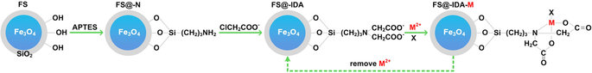](http://www.nature.com/articles/srep21027/figures/1)

FS, Fe3O4@SiO2; APTES, γ-aminopropyltriethoxysilane; FS@-N, surface-aminated FS; FS@IDA, magnetic solid trimethylene iminodiacetic acid chelator; FS@IDA-M, magnetic solid chelate complex; M2+, divalent heavy metal ion.

**[Full size image](http://www.nature.com/articles/srep21027/figures/1)**

Transmission electron microscope (TEM) images showed that the MNPs aggregates (dark gray) were coated with SiO2 membranes (light gray), indicating that the FS@IDA material had a multi-core, core-shell structure with a particle diameter of 0.3–3.0 μm ([Fig. 2a](http://www.nature.com/articles/srep21027" \l "f2)). In the XRD pattern of FS@IDA, a broad peak was observed near 2θ = 23°, indicating the presence of non-crystalline SiO2 ([Fig. 2b](http://www.nature.com/articles/srep21027" \l "f2)). The FTIR spectra of FS, FS@-N and FS@IDA ([Fig. 2c](http://www.nature.com/articles/srep21027" \l "f2)) exhibited Si-O-Si vibration peaks at approximately 1100 and 470 cm−1 and a characteristic Fe3O4 adsorption peak at approximately 588 cm−1. The wide peak in the FS spectrum at about 3448 cm−1 was assigned to the vibration peak of hydrogen-bonded surface silanol groups. The intensity of this peak was weaker in the FS@IDA spectrum, suggesting that some of the silicon hydroxyl groups participated in the organic-inorganic reaction. The methylene vibrations of FS@-N and FS@IDA were observed at approximately 2930 and 2850 cm−1, respectively, and FS@IDA also exhibited a strong carboxyl adsorption peak at approximately 1430 cm−1. The results indicate that iminodiacetate groups were grafted on the FS surface. The amido group concentration of FS@-N was measured to be in the range of 0.035–0.067% (corresponding to 0.025–0.047 mmol·g−1) by the Kjeldahl nitrogen method and the pH of the solution was in the range 3 to 6. It was therefore assumed that the chelating group loading occurred in this amido group concentration range.

**Figure 2: Structure and characterization of the FS@IDA material.**

[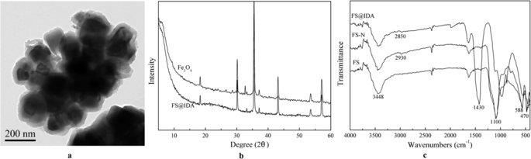](http://www.nature.com/articles/srep21027/figures/2)

(**a**) Transmission electron microscope image of FS@IDA. (**b**) X-ray diffraction patterns of Fe3O4 and FS@IDA. (**c**) Fourier transform infrared spectroscopy spectra.

**[Full size image](http://www.nature.com/articles/srep21027/figures/2)**

The sorption and acid desorption experiments using FS@IDA samples were repeated three times, and the nitrogen concentration of the initial sample and the acid desorption for the first, second and third times was measured continuously. They measured nitrogen concentration were 656, 646, 614 and 642 μg·g−1(corresponding to 0.047, 0.046, 0.044 and 0.046 mmol), respectively. There was no decrease in the nitrogen concentration, which meant that the reduction of the effective group was relatively small, and the FS@IDA could be reused.

## **Magnetic properties of FS@IDA**

The magnetic properties of FS@IDA (0.0455 g) were analyzed ([Fig. 3](http://www.nature.com/articles/srep21027" \l "f3)). According to the hysteresis loop, the coercivity of FS@IDA was approximately 90 Oe, obviously indicating soft magnetic material. The saturation magnetization of FS@IDA was lower than that of Fe3O4, and declined by 7.6% in a small range due to the introduction of nonmetallic elements (C, N, O and Si), as well as the antimagnetic and covering effect of the nonmetallic elements. This effect also showed that the surface of Fe3O4 was coated completely. The slight decrease of saturation magnetization might be due to the effect of a thinner surface-coated modification layer.

**Figure 3: Magnetic hysteresis loop of FS@IDA.**

[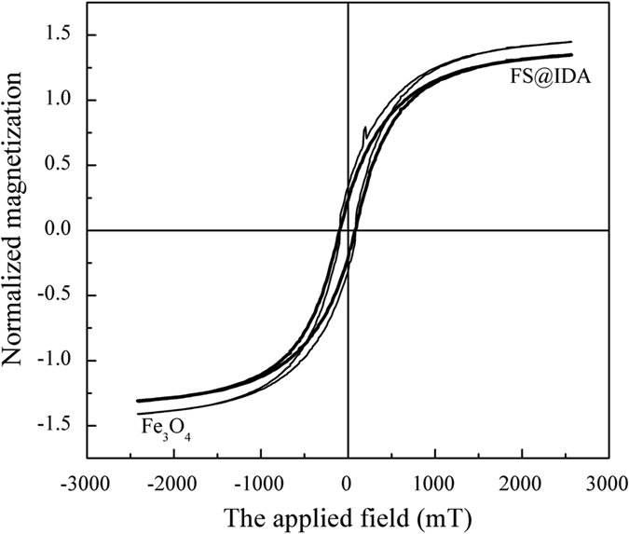](http://www.nature.com/articles/srep21027/figures/3)

**[Full size image](http://www.nature.com/articles/srep21027/figures/3)**

The experiment measured the magnetic properties of fresh soil and soil treated with FS@IDA after magnetic separation. The recovery rate of FS@IDA was expressed as the ratio of dried FS@IDA (2.96 g) after magnetic separation to the amount added to the initial sample (3 g). The results show that 98.7% of the FS@IDA can be recycled. Errors were likely to have occurred during sample weighing and cleaning, so it is likely that this new material will be recyclable. Moreover, the main constituent of the material was iron, silicon and a novel reactive magnetic carrier created by coating the inorganic surfaces of a magnetic powder (FS) with iminodiacetic acid chelators (FS@IDA) via organic synthesis reactions, so there is no potential environmental risk.

## **Effect of the pH on the amount of Cd2+ adsorbed on FS@IDA**

The number of solvated divalent metal ions adsorbed on FS@IDA was affected by the pH, adsorption time, FS@IDA quality, initial cadmium concentration and presence of other ions. Initially, 1 g of FS@IDA was added to 100 mL of 0.89 mM and 2.67 mM cadmium solutions, which were then maintained at room temperature for 12 h. The effects of the pH, the initial Cd2+ concentration and the presence of other ions on the amount of Cd2+ adsorbed were determined, and the results are shown in [Fig. 4](http://www.nature.com/articles/srep21027" \l "f4).

**Figure 4: Effects of the presence of other cations on the quantity of Cd2+adsorbed at different pH.**

[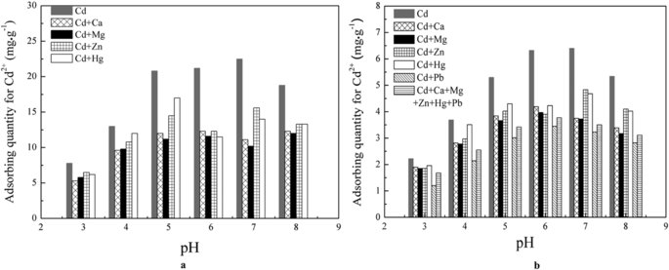](http://www.nature.com/articles/srep21027/figures/4)

(**a**) Initial Cd2+ concentration of 2.67 mM. (**b**) Initial Cd2+ concentration of 0.89 mM.

**[Full size image](http://www.nature.com/articles/srep21027/figures/4)**

As shown in [Fig. 4a,b](http://www.nature.com/articles/srep21027" \l "f4), the amount of Cd2+ adsorbed increased with increasing pH and reached a maximum when pH was between 6 and 7. Above pH 7, the amount adsorbed decreased. The H+ concentration decreased with increasing pH, resulting in a decrease in the reactions between the carboxylate radicals, nitrogen atoms and H+ ions and increased chelation of Cd2+. However, the cadmium ion easily formed a hydrate under alkaline conditions, hindering its adsorption. When the initial Cd2+concentrations were 0.89 mM and 2.67 mM, the maximum adsorption capacities of FS@IDA were about 6.40 mg·g−1 and 22.5 mg·g−1, respectively.

The adsorption behavior included both chemical and physical adsorption, and the maximal amount of Cd2+ adsorption was related to the initial Cd2+ concentration. Generally, the higher the initial concentration, the greater the adsorption quantity. So the adsorption of Cd2+ was higher than the nitrogen load. Where as, the nitrogen concentration of the sample was measured by a semi-micro Kjeldahl determination, and the results from this method were usually low, resulting in the adsorption capacity of the actual dynamic adsorption curve being larger than the nitrogen load, which denoted the quantity of the chelation group of the FA@IDA material.

Furthermore, Ca2+, Mg2+, Zn2+ and Hg2+ adsorption might compete with Cd2+adsorption. The effects of Ca2+ and Mg2+ on the amount of Cd2+ adsorbed were the same and slightly greater than those of Zn2+ and Hg2+. In addition, when a solution containing equal amounts of Cd2+ and Pb2+ was used, the amount of Cd2+ adsorbed decreased by approximately 50%, showing that the presence of Pb2+ had a larger impact on cadmium adsorption than the other ions. These results indicate that FS@IDA can be used to selectively capture and separate solvated Cd2+ and Pb2+ions.

## **Chelating capture of several sparingly soluble heavy metals**

Several insoluble carbonate powders (M = Cd, Zn, Pb, Cu, Ni), lead sulfate and lead chloride were added to 100 mL of aqueous solutions at pH 7. The heavy metal-ion concentrations in the solutions were 100 mg·L−1 (Cd: 0.89 mM, Zn: 1.53 mM, Pb: 0.49 mM, Cu: 1.57 mM, Ni: 1.69 mM). FS@IDA (3.5 g, the chelating group concentration was greater than 1.75 mmol·g−1) was added to the solution, which was intermittently stirred for 12 h at room temperature. The magnetic solid was separated using a magnet; the insoluble carbonate, sulfate and chloride powders were removed; and the suspension became clear ([Supplementary Experiment S1](http://www.nature.com/articles/srep21027" \l "s1)).

In this study, the solubility of cadmium carbonate and the ion concentration were both low in the solution, so the effect of ionic strength on the solubility product could be ignored. In addition, the FS@IDA material was mainly used for soil heavy metal removal, and the conversion of heavy metal adsorption and precipitation would not result in a the pH change in the strong soil buffer system. Therefore, the aqueous solutions were adjusted to pH 7.

The solubility and concentration product constants correspond to the equilibrium conditions and to the actual experimental conditions, respectively. The results of the precipitate dissolution and heavy metal capture experiments are shown in [Table 1](http://www.nature.com/articles/srep21027" \l "t1). When an appropriate amount of FS@IDA was used, the Cd, Zn, Pb, Cu and Ni ions in the insoluble carbonate and the PbSO4 and PbCl2 compounds suspended in solution formed magnetic solid chelates with FS@IDA-M, allowing magnetic removal ([Fig. 1](http://www.nature.com/articles/srep21027" \l "f1)), but the ions of the corresponding phosphate compounds did not form chelates with FS@IDA.

**Table 1: Results for the dissolution of several insoluble compounds suspended in solution and the corresponding metal ion capture.**

**[Full size table](http://www.nature.com/articles/srep21027/tables/1)**

Based on solubility equilibrium theory, when the ion concentration product constant *Ksp*′ is less than the solubility product constant *Ksp* of the insoluble salt, the insoluble salt dissolves.

The dissociation constants of H2CO3 in water are *Ka1* = 4.2 × 10−7 and *Ka2* = 5.6 × 10−11. The acid effect coefficient of CO32− is

IMG_260IMG_261

In this study, lead carbonate was used as an example to demonstrate precipitate dissolution.

IMG_262IMG_263

s = 1.28 × 10−5.

IMG_264

The [Pb2+]′ concentration of the solution was 1.01 × 10−6 M 12 h after the FS@IDA powder was added. Because

IMG_265

PbCO3 was dissolved in the solution, leading to the formation of FS@IDA-Pb.

The dissociation constants of H3PO4 in water are *Ka1* = 7.6 × 10−3, *Ka2* = 6.3 × 10−8and *Ka3* = 4.4 × 10−13. The acid effect coefficient of PO43+ is

IMG_266IMG_267

In this study, Zn3(PO4)2 was used as an example to demonstrate why precipitate dissolution did not occur.

With *Ksp* = 9.1 × 10−33, IMG_268 = 1.02 × 10−25, and IMG_269 >*Ksp*, the precipitate did not dissolve.

Lead sulfate and lead chloride were not hydrolyzed, and for these compounds, IMG_270 < *Ksp*; therefore, these precipitates dissolved.

These results show that FS@IDA could promote the dissolution of some insoluble metal salts by capturing the metal ions with their chelating surface groups ([Fig. 1](http://www.nature.com/articles/srep21027" \l "f1)), allowing for the targeted magnetic separation of multi-phase non-magnetic metal.

## **Energy spectrum characterization of FS@IDA-Cd**

In this study, the FS@IDA-Cd powder sample was obtained by magnetic separation. After drying the sample at 105 °C, its surface elements were analyzed with SEM-EDS[22](http://www.nature.com/articles/srep21027" \l "ref22" \o "Tessier, A., Campbell, P. G. C. & Bisson, M. Sequential extraction procedure for the speciation of particulate trace metals. Anal. Chem. 51, 844 (1979).). The red dots ([Fig. 5d](http://www.nature.com/articles/srep21027" \l "f5)) and green dots ([Fig. 5e](http://www.nature.com/articles/srep21027" \l "f5)) in the full energy spectrum represent carbon and nitrogen atoms, respectively, which were introduced during the grafting reaction. The purple dots represent cadmium ions chelated by FS@IDA ([Fig. 5f](http://www.nature.com/articles/srep21027" \l "f5)). Based on the energy spectrum, the nitrogen and cadmium loadings were found to be 3.57 and 1.07 wt%, respectively ([Fig. 5c](http://www.nature.com/articles/srep21027" \l "f5)).

**Figure 5: SEM-EDS of FS@IDA-Cd.**

[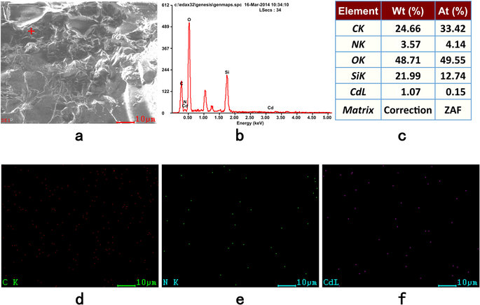](http://www.nature.com/articles/srep21027/figures/5)

(**a**) SEM image. (**b**) EDS point spectrum. (**c**) Relative elemental content at the corresponding point. EDS images showing the locations of (**d**) C, (**e**) N, and (**f**) Cd atoms.

**[Full size image](http://www.nature.com/articles/srep21027/figures/5)**

## **Chelation and magnetic separation of Cd and Pb in soil**

Heavy metals are found in different chemical forms in soils, and those forms have different activities in reactions such as dissolution, precipitation, coagulation and complex formation. Tessier *et al.*[22](http://www.nature.com/articles/srep21027" \l "ref22" \o "Tessier, A., Campbell, P. G. C. & Bisson, M. Sequential extraction procedure for the speciation of particulate trace metals. Anal. Chem. 51, 844 (1979).) classified sediments and heavy metals in soils into different fractions; water-soluble, interchangeable, carbonate-bound, iron-manganese oxide-bound, organic-bound and residual fraction. The chemical stability of the different heavy metal fractions is as follows: residual >organic-bound >iron-manganese oxide-bound >carbonate-bound >interchangeable >water-soluble.

The topsoil near a lead and zinc refinery in Zhuzhou, Hunan Province, was chosen because it is representative of soils that are significantly contaminated by heavy metals. This factory specializes in heavy metals such as Pb, Zn, and Cu and their alloys and combines non-ferrous heavy metals such as Au, Ag, Cd, In, Ge, Ga, Se and Te, with chemical industry products such as vitriol. The cadmium and lead concentration was determined to be 10.91 ± 2.06 mg·kg−1 and 190.0 ± 33.2 mg·kg−1([Table 2](http://www.nature.com/articles/srep21027" \l "t2)), respectively, using the GB/T17138–1997 standard method[23](http://www.nature.com/articles/srep21027" \l "ref23" \o "Qi, W. Q. & Liu J. Soil quality—determination of lead, cadmium—graphite furnace atomic absorption spectrophotometry in the State Standard of the People’s Republic of China (eds National Environmental Protection Agency & State Administration of Quality Supervision) 1-5 (GB/T 17141-1997, 1997).). The heavy metal forms were analyzed using the Tessier method[22](http://www.nature.com/articles/srep21027" \l "ref22" \o "Tessier, A., Campbell, P. G. C. & Bisson, M. Sequential extraction procedure for the speciation of particulate trace metals. Anal. Chem. 51, 844 (1979).).

**Table 2: Total concentration and different fraction content of Cd, Pb, Cr, Zn, Hg and As in the soil sample (Mean ± SE, mg·kg−1).**

**[Full size table](http://www.nature.com/articles/srep21027/tables/2)**

To measure the amount of cadmium and lead removed from the soil, a slurry of 50 g of soil and 150 g of distilled water was prepared. The pH was adjusted between 6 and 7, and 5 g of FS@IDA was added to the slurry at room temperature. The magnetic solids were separated using a magnet after intermittent stirring for 7 d. The cadmium and lead concentration in the soil was reduced to 1.639 and 52.7 mg·kg−1 ([Table 2](http://www.nature.com/articles/srep21027" \l "t2)), corresponding to removal percentages of 84.9 and 72.3%, respectively. These results suggest that the water-soluble, interchangeable, carbonate-bound and iron-manganese oxide-bound fractions of Cd and Pb (but not the organic-bound or residual fractions in the multi-phase soil system) could form the magnetic solid chelates FS@IDA-Cd and FS@IDA-Pb, which were subsequently separated using a magnet ([Fig. 1](http://www.nature.com/articles/srep21027" \l "f1) and [Supplementary Experiment S2](http://www.nature.com/articles/srep21027" \l "s1)). This novel magnetic solid chelator as prepared in this study has potential for use in magnetic separation applications and in the removal of heavy metal contaminants from soil.

FS@IDA-Cd (1 g) was immersed in 1.0 M hydrochloric acid (100 mL) for 1 h, resulting in the desorption of more than 85% of the cadmium ions. The Cd2+removal rate by FS@IDA was still greater than 55% after three adsorption-desorption cycles, indicating that this material can be recycled.

Related studies have reported that MNPs with high efficiencies can be used to remove heavy metals, such as Cd, Pb, Cu, Hg[24](http://www.nature.com/articles/srep21027" \l "ref24" \o "Liu, J. K. et al. Coating Fe3O4 magnetic nanoparticles with humic acid for high efficient removal of heavy metals in water. Environ. Sci. Technol. 42, 6949 (2008).),[25](http://www.nature.com/articles/srep21027" \l "ref25" \o "Wassana Y. et al. Removal of heavy metals from aqueous systems with thiol functionalized superparamagnetic nanoparticles. Environ. Sci. Technol. 41, 5114 (2007).),[26](http://www.nature.com/articles/srep21027" \l "ref26" \o "Liu, X. W. et al. Magnetic chitosan nanocomposites: A useful recyclable tool for heavy metal ion removal. Langmuir 25, 3 (2009).), in aqueous solution. In this study, it was not emphasized that FS@IDA was a nanometer material. In fact, it was a multi-core, core-shell structure and the average particle size was not of nanomaterial particle size. Moreover, the nanoscale magnetic adsorption material is too small, while in the soil-liquid system and heterogeneous soil system, because of the fixation effect of soil clay, it is difficult for it to be completely separated, so the FS@IDA size was controlled in the range of a few microns to dozens of micrometers. The FS@IDA material was applied in a solid-liquid soil system and a heterogeneous soil system. The condition of the soil system was more complicated than in an aqueous solution. It was demonstrated that the FS@IDA had the potential to chelate sedimentary heavy metals (M) such as carbonates, sulfates, phosphates, and iron-manganese oxide-bound fractions, into soluble magnetic solids that were easy to separate magnetically.

## **Chelation mechanism**

The reaction between cadmium ions and FS@IDA illustrates the chelation mechanism. Both the nitrogen and oxygen atoms of the iminodiacetic acid chelating group have electron pairs that can coordinate with metal ions, resulting in a tridentate chelator structure. The FS@IDA surface has many alkyl iminodiacetic acid chelating groups that can coordinate with metal ions via the nitrogen and oxygen atoms to form stable four-coordinate, three-coordinate, and double five-membered ring chelates[27](http://www.nature.com/articles/srep21027" \l "ref27" \o "Xu, M. et al. Study on the adsorption of Ca2+, Cd2+ and Pb2+ by magnetic Fe3O4 yeast treated with EDTA dianhydride. Chem. Eng. J. 168, 737 (2011).). In addition, the cadmium ion has an 18-electron shell structure with an unoccupied orbital, a relatively small ionic radius and a relatively strong electronegativity and can therefore readily form six-coordinate or four-coordinate complexes[28](http://www.nature.com/articles/srep21027" \l "ref28" \o "Warad, I. et al. Design and structural studies of diimine/CdX2(X = Cl, I) complexes based on 2, 2-dimethyl-1, 3-diaminopropane ligand. J. Mol. Struct. 1062, 167 (2014).). Possible chelation reaction equations and the resulting FS@IDA-Cd structure showing the coordination of the FS@IDA chelating groups to the cadmium ion are shown in [Fig. 1](http://www.nature.com/articles/srep21027" \l "f1).

The magnetic solid chelate FS@IDA-Cd had cadmium ions coordinated with four atoms, the nitrogen and two oxygen atoms of a chelating group and solution species. H2O, OH− or halogen ion in a double five-membered ring configuration. Therefore, it was assumed that the cadmium ions were captured via a chelating adsorption reaction on the FS@IDA surface or at the solid-liquid interface.

The effect of the adsorption time on the amount of Cd2+ adsorbed on FS@IDA at different temperatures was measured. FS@IDA (1 g) was added to a 100 mg·L−1Cd2+ solution (100 mL) and the pH was adjusted to 7. The temperature was set to 293, 303, or 313 K. The cadmium adsorption increased rapidly within the first 0.5 h, reaching over 75% of the maximum adsorption, indicating that these ions can be quickly captured by FS@IDA ([Fig. 6a](http://www.nature.com/articles/srep21027" \l "f6)). The formation of chemical bonds during the adsorption process was the key factor affecting the secondary dynamic adsorption IMG_272 and it was further assumed that cadmium was mainly adsorbed on FS@IDA via chelation ([Fig. 6b](http://www.nature.com/articles/srep21027" \l "f6)).

**Figure 6: Amount adsorbed and adsorption dynamics at different temperatures.**

[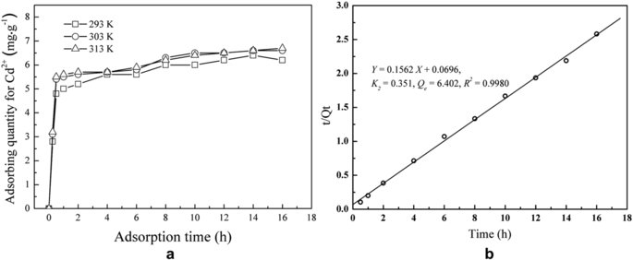](http://www.nature.com/articles/srep21027/figures/6)

(**a**) Effects of the adsorption time on the amount of Cd2+ adsorbed on FS@IDA at different temperatures. (**b**) Data at 293 K were simulated using a quasi-secondary dynamics model, IMG_274, where k2 is the adsorption rate constant, *Q*e is the amount adsorbed at equilibrium (mg·g−1) and *Q*t is the amount adsorbed at time t (mg·g−1).

**[Full size image](http://www.nature.com/articles/srep21027/figures/6)**

**Conclusions**

To achieve highly selective, efficient heavy metal removal from contaminated soil, a novel inorganic-organic hybrid material, magnetic solid chelator powder FS@IDA, was prepared. The inorganic FS particles displayed soft magnetism, and the organic alkyl iminodiacetic acid groups on the particle surface can capture heavy metals via chelation. Specifically, FS@IDA can coordinate with the heavy metals (M) of Cd, Zn, Pb, Cu and Ni carbonates, lead sulfate and lead chloride, which were insoluble in the aqueous systems tested, to form FS@IDA-M for magnetic separation. Only the organic-bound and the residual metal species in the soil cannot be chelated by FS@IDA. Moreover, FS@IDA-M could be easily reprocessed and recycled via acid treatment. This material has the potential to be used to selectively remove non-magnetic heavy metals from multi-phase soil systems under natural conditions via magnetic separation and could potentially be used to purify and manage large areas of farmland contaminated with heavy metals.

**Methods**

## **Materials**

Fe3O4 powders (Tianjin Bodi Chemical Engineering Co., Ltd.,Tianjing, China), tetraethoxysilane (TEOS) (Tianjin Fuchen Chemical Reagent Factory, Tianjing, China), APTES (Hubei Wuda Organosilicon New Material Co., Ltd., Wuhan, China), and sodium chloroacetate (Tianjin Guangfu Fine Chemical Research Institute, Tianjing, China) were employed.

## **Apparatus**

TEM (Hitachi H-800), SEM (Hitachi SU-8010), XRD (Bruker AXS D8 Focus), Avatar 370 FTIR (US Nicolet), VSM (HH-10, Nanjing Nanda Instrument Plant), and Z-2000 AAS (Hitachi) instruments were employed.

## **Preparation of FS**

TEOS (9 g) and Fe3O4 powder (10 g) were stirred into 70 mL of anhydrous ethanol at 50 °C. Then, a solution of 12 mL of ammonium hydroxide, 30 mL of ethanol, and 14.4 mL of deionized water was added dropwise to the suspension under stirring, and the mixture allowed to react for 8 h. The product was separated using a magnet and washed with water. Finally, the resulting FS powder was vacuum-dried at 70 °C to a constant weight.

## **Synthesis of FS-N**

The FS powder (5 g) was added to 150 mL of anhydrous ethanol, and 1 g of APTES was added after stirring. The reaction solution was adjusted to pH 5. The reaction was maintained at 40 °C for 5 h. After the reaction, the product was separated using a magnet and washed with water. The magnetic FS-N particles were dried at 105 °C to generate the aminated multi-core core-shell structure.

## **Carboxymethylation reaction on the FS-N surface**

FS-N (5 g), 3 wt% sodium chloroacetate (100 mL), and a 10 v/v% ammonia solution (10 mL) were dissolved in 100 mL of distilled water. The reaction solution was maintained at 70 °C for 8 h. Then, the product was separated using a magnet and washed with distilled water. The FS@IDA powder was obtained by the nucleophilic substitution reaction of FS@-N with sodium chloroacetate after drying at 105 °C.

## **The reutilization measurement of FS@IDA**

Soil samples (30 g, 100-mesh seived) were added to 75 ml of distilled water and stirred for 10 min to prepare a soil suspension with a soil water ratio of 2.5. A columnar magnet with a magnetic field intensity of 5000 gauss was used to remove magnetic materials from the soil suspension. FS@IDA (3 g) was added to the soil suspension and stirred for 30 min. Then, the samples were magnetically separated after standing for 120 min, and the soil particles from the FS@IDA surface were washed with distilled water, dried at 70 °C and weighed

## **Calculating the cadmium concentration in the solution**

A cadmium solution with a given concentration was placed in a beaker and FS@IDA added. The pH was adjusted. After reacting at room temperature, the final product was separated using a magnet. The residual cadmium concentration in the solution was measured to calculate the amount adsorbed on FS@IDA and the cadmium removal rate.

The formula for calculating the amount adsorbed is

IMG_275

The formula for calculating the cadmium removal rate is

IMG_276

The initial concentration and volume of the cadmium solution are denoted by C0(mg·L−1) and V0 (mL), respectively. The concentration and volume of the cadmium solution after the adsorption reaction are designated C1 (mg·L−1) and V1 (mL), respectively. The mass of FS@IDA used is m0 (g).

## **Calculating the FS@IDA desorption rate**

Saturated FS@IDA-Cd (1 g) was immersed in 100 mL of 1 M hydrochloric acid and the magnetic substances were separated using a magnet after the cadmium was allowed to desorb by stirring at room temperature for 1 h. The cadmium concentration in the solution was measured, and the desorption rate was calculated as:

IMG_277

The concentration and volume of the cadmium solution after desorption were denoted by C2 (mg·L−1) and V2 (mL), respectively. The mass of cadmium adsorbed by FS@IDA was denoted m2 (g).

**Additional Information**

**How to cite this article**: Fan, L. *et al.* Chelating capture and magnetic removal of non-magnetic heavy metal substances from soil. *Sci. Rep.* **6**, 21027; doi: 10.1038/srep21027 (2016).